|  |  |
| --- | --- |
| Date | 9 JULY 2024 |
| Team ID | INDIVIDUAL |
| Project Title | CareerCraft: ATS-Optimized Resume Analyzer using Gemini Model |
| Maximum Marks | 6 Marks |

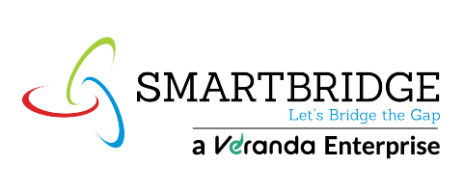**Model Development Phase Template**

|  |  |  |  |
| --- | --- | --- | --- |
| **Model** | **Description** | **Hyperparameters** | **Performance**  **Metric (e.g.,**  **Accuracy, F1**  **Score)** |
| Gemini Pro | Advanced NLP model for resume analysis and keyword extraction. | -- Custom prompts  - Optimized API settings | Accuracy score =  81% |